SVI FF differences between Rev. 3 and 2

# New features

## Manufacturer’s Id change

Changed from 0x004745 (GE) to Baker Hughes (0x445644). Provided framework for FF live firmware download between R2 and R3 accounting for different manufacturer’s ids.

## Partial Stroke Test

Implemented PST to run in AUTO or MAN mode of TB with various process-related abort conditions and several patterns of setpoint excitation (26097)

## Data Collection

Diagnostic data collection can be triggered to start by various conditions (26398) including setpoint, position, and/or pressure deviation (50671) and TB alerts. It comes with a presampling feature to include data before the trigger.

## New diagnostic process interface

PST and data collection can now start automatically based on trigger events. Because of that, a guard is implemented to avoid clobbering the diagnostic buffer.

Lock the buffer semaphore to preserve the content of the buffer, override the lock.

Added data collection state monitor for testing (70176-70178) and add info to the buffer header (80586, 80599)

## Physical Analog Input

Analog input is now a TB parameter and a new channel in AI FB (27101)

## DO Function Block Channel FAULT and TB_FSTATE_STATUS

Now DO FB can cause fault state in TB to enhance device application (25082, 27391, 27869)

## Firmware download

TB factory defaults used to be lost on firmware upgrade. Now, current settings are automatically set as new factory defaults (26713)

## DD features

“Replace stops” is now supported (67696)

## Write lock

Write lock behavior re-implemented to comply with new FF spec (67721)

# Major improvements

## Network parameters

Tighter network parameters are allowed. Max response delay can be 3 (down from 5 in Rev.2), allowing SVI FF to replace FVP (26918). However, at tighter parameters, “geometry” (MRD*slot_time >=24) considerations should be made. E.g. MRD=3 won’t work with slot time <8.

## Field Diagnostics

TB alerts are now mapped to RB.FD_SIMULATE.DIAGNOSTIC_VALUE thus enhancing the functionality (27333)

## Inter-CPU communications

Inter-CPU communications (IPC) made faster and more robust (29544, 31252).  
This improvement made Network parameters  improvement possible.

Failure of IPC no longer break FF communications. On the contrary, RB.RESTART=Processor may be attempted to kick-start IPC (29544)

HART over FF now admits all commands that HART over ISP does (54110)

## DD major redesign

FD alerts redesign (60733)

Support of Trex handheld (67658-67694)

Display no longer disappears instantly (70142)

TRANSDUCER_DIRECTORY parameter removed from menus (70171)

Autotune method uses correct pressure units (70172)

Corrected detection of running process (70173)

Optimized menu structure and methods implementation (70175-70176)

## Local UI

Button lock added to DD (61923)

UI password added to DD (61924)

# Interoperability improvements

## Ease of operation / User experience

The critical ADVANCED key is no longer lost in any RB operations (25006, 52797)

RB restart defaults or factory no longer induce fault “find stops failed” to require new find stops. That’s because stops no longer restored (27309)

TB now allows to enter AUTO mode even if FINAL_VALUE is not GOOD. In this case, it will reinitialize the value with the current valve position (25305)

Added RB RESTART option to make sensible defaults across FB, such as e.g. CHANNEL (53057)

## Compliance with FF specification

### CS FB

Non-volatile memory use is brought up to the spec

### Block modes

RB and TB block mode parameters are now standard. This resolves interoperability with Honeywell (41985)

RB target mode no longer changes programmatically (if APP is in failed state) (41808)

### XD_ERROR

A XD_ERROR bit is set if and only if BLOK_ERR “Other” bit is set (41895)

All XD_ERROR parameters now have underlying type “unisigned 8” (41983)

### Field Diagnostics

Field Diagnostics recommended action could be set without FD alert and mismatched against xd_error (41896)

### RB write lock behavior

The code has been rewritten to comply with FF spec (42541, 43408). In particular, handover protocol between Soft and Hard lock is now correct. The lock now works correctly on both CPUs.

### Block Errors

Block errors originating from TB alerts are by default apportioned between TB and RB without duplication. Old option (TB only and copy all to RB) are still available for special purposes (42604)

“Power up” block error bit is now reserved and is not set ever (45379)

### ITK

Firmware defaults are now sufficient to pass the tests (53056)

# Other improvements

## Non-volatile memory management and recovery

NV memory objects are now small and the writes to the larger of them is delegated. This avoids spikes in block execution times. (25535, 26325)

TB FINAL_VALUE_D and _DINT are no longer saved in NV memory, just like the analog FINAL_VALUE. That improves timing (26226)

We don’t attempt to rescue Rev.2 NV memory, but going forward, FFP CPU firmware up/downgrade will preserve all settings transparently to the user (26431, 28833)

It is now possible to completely reinitialize FFP CPU NV memory by writing RB.RESTART=169 (26933)

Restore TB to factory now handles TB STATIC_REV consistently: if APP CPU succeeds, increment by 1, if FFP CPU, by 2, so overall success is indicated by ST_REV incremented by 3 (27310)

## Control and Autotune

Corrected multiple Autotune bugs by bringing over ESD fixes and extending check for stability (28298)

Eliminated iterative artificial control windup due to multiple resets (42245, 42247)

Eliminated possible division by 0 and possible positive feedback (42246)

Removed bias reduction on startup for ATC (42248)

Corrected bias initialization sequence (was always to 0 deg.C) (42249)

Minimized the possibility of saving wrong bias, including but not limited to numeric overflow (32844, 32715, 42250, 42261)

Implemented consistent reinitialization of state variables on entering closed-loop control (42251, 42252)

Corrected evaluation of “bias out of range” fault (42262)

## Local UI

Manual and automatic “find stops” now consistently display raw position (25204)

On Autotune failure, LCD displayed “FAILURE” which confused a lot of people. Now it displays “TUNE ERR” (28185)

It is now possible to write LCD temperature calibrations, as a factory operation (44277)

SIMULATN menu on entry didn't show the actual "jumper" state (53769)

## Robustness

Flash bank written to during FW download is no longer left open between commands (25239)

Watchdog now monitors event-driven tasks in both CPUs (26424, 26453)

Watchdog in FFP CPU now exclusively follows a stringent tickle policy like APP (29102)

NV memory management now tests and repairs the last write before unexpected reset in both CPUs. That protects against repeated resets. (26312)

## Firmware download

Firmware download is now about twice as fast as in R2 (29609)

Firmware download/activation state machine brought to FF compliance to the extent possible without Softing and made robust against power loss at various phases of activation (43858, 54031, 54032)

## Testability and troubleshooting

Function blocks’ execution time can now be monitored (25348)

It is now possible to monitor performance of interprocessor communications on each CPU (26926, 29245, 29247, 29544)

Propagation of failed state to APP CPU is now indicated in TB COMPLETE_STATUS (29250)

“HART pass-through” interface now supports all commands to APP, as well as intercepts for FFP (42259)

“HART pass-through” commands to FFP that change device behavior now require factory mode (43410)

“HART pass-through” can now connect to the device even if IPC is not operational (43474)

“Firmware Info” command now returns the APP build changeset instead of month/day (43597)

CPU traps now point to the instruction just past the offending instruction, making it useful for debugging (43954)

Added sufficient interfaces to run ITK tests remotely (52857)

Added SPC-42 (FF chip) lockup monitoring using base.a provided by Markus Bachmann in 2016 (54066)

Added task statistic access via hart (54112)

## Physical DI

Digital input toggling may take a long time over long wires, and can be missed if changed rapidly. Like in ESD where the effect was first discovered, power to DI is no longer switched (26635, 27928)

## Processes/Methods

A process leaving data in the diagnostic buffer no longer auto-terminates. Instead, it indicates completion by 200% complete to allow the data upload and prevent data collection from overwriting the buffer (50612)

## TB trends, histograms, and alerts

Deviation alert is no longer calculated in CUTOFF on either side (53774)

Near-close alert is no longer calculated in CUTOFF_LO (53774)

Implemented consistent design of trends (53206). In particular:

Implemented methods to reset trends, working time, and histograms (53085, 53701)

## Miscellaneous

Lifetime min/max temperatures are added to TB TEMPERATURE_EXTREMES (52485)

Brought TB defaults in conformance to ITK test (52729, 52826, 52857, 53056)

# Corrections and bug fixes

## Serious issues

In some cases, writing to NV memory could fail without any indication (25006, 25012, 25044)

DO FB back calculations limit status don’t account for reverse action (25418)

Fail Open/Close did the exact opposite for ATC configuration (28722)

Mismatch of Softing GW script definitions with DD and firmware is corrected by automation. The user-facing effect was unclear but could be memory overwrite due to size mismatch (26238)

Incorrect fix-up (in restore factory) of what is enabled per “Advanced” key is corrected (27832)

Parameter read filter may corrupt live TB parameter causing incorrect function block application behavior. This has been corrected (27808)

DO FB, BLOCK_ERR bit READBACK_CHECK_FAILED could be overwritten (41910)

When TB is in MAN mode, setpoint delivery to APP CPU was ignored. That caused incorrect behavior for APP-only resets and XD_FSTATE failover interface (42282)

Incorrect handling of TB alerts with RB restart defaults has been fixed (53074)

TB Alerts with time-to-wait were to spontaneously disappear in ~49 days. This has been fixed (53084)

Many TB alerts + failed state time would overflow in ~45 days yielding incorrect results (53610)

RB.RESTART=Resource now clears sources of BLOCK_ERROR (81555)

## Less serious issues

TB.XD_FSTATE configuration limits are corrected (25464)

A mix-up in noise calculation between raw position and position in % range is corrected (26170)

Incorrect changing of TB static revision (e.g. in working time alert/working times) is fixed (26349)

Not all alerts make it to alerts log. This has been corrected (27389)

final_position_value was filled with uncharacterized position if readback_select == READBACK_SELECT_WORKINGPOS. This has been corrected (53062)

TB trends’ current values may jump unexpectedly on RB restart defaults (53197)

Travel accumulation trend missed increments <1%/s (53247)

Trends values were unchanged when travel unit changed (53197)

Setpoint timeout alert didn’t clear current and history state when disabled (53608)

Near-closed alert didn’t clear history state when disabled (53608)

Ranges of pressure parameters didn't change when pressure units change (53611)

Position error histogram calculations could overflow (53772)

# Partial Stroke Test

As an incidental improvement, allowed setpoint range limits are widened (26855)

PST data can be read out while PST is still running (26867)

# Extension of XD_FSTATE functionality

1.      XD_FSTATE controls fallback to a setpoint as configured (full closed, full open, stay in position, fixed setpoint) on the following conditions:

a.      Controlling output block, according to TB.SETPOINT_SOURCE has FINAL_VALUE_x.STATUS BAD or substatus “Initiate failed state”.

                                                    i.     In this case, the time is counted and when it reaches FSTATE_TIME_1, the fallback setpoint is used

                                                   ii.     When TB changes actual mode to AUTO, the time counter is reset

b.      A DO FB has CHANNEL=CH_DO_FAULT and its output is GOOD and TRUE

                                                    i.     In this case, the fallback setpoint is used immediately

                                                   ii.     The DO FB request is latched until changed to GOOD and FALSE

                                                  iii.      When the DO FB output is not GOOD, the last GOOD request is latched, in particular, when the DO FB is stopped (such as OOS).

1.      This is so even if the FB is no longer scheduled

2.      To cancel a stale DO FB request, the user can:

a.      change the CHANNEL of the DO FB to something else, or

b.      write 0 to FSTATE_STATUS.REQUEST (see below)

2.      At most one DO FB may have CHANNEL=CH_DO_FAULT

3.      When the fallback setpoint is used, it is indicated in SETPOINT.STATUS substatus “Initiate failed state”.

4.      FSTATE_STATUS parameter (new) indicates

a.      Flag of active fallback due to DO FB or user request

                                                    i.     Writing a 0 will cancel DO FB request, whether stale or not. If not stale, next execution of the DO FB will refresh it.

**ii.     Writing a 1 will have the same effect as DO FB request, whether or not there is a DO FB that could make such a request**

b.      Flag of active fallback due to FINAL_VALUE_x, read-only

c.      Time until activation of fallback due to FINAL_VALUE_x, read-only

5.      On reset/power-up, TB doesn’t preserve any old DO FB requests and starts with fresh XD_FSTATE internal state, just as it does w.r.t. FINAL_VALUE_x.

(28831)

# FD Diagnostics

In complement to R2 limited FD alerts, the following mapping is in R3:

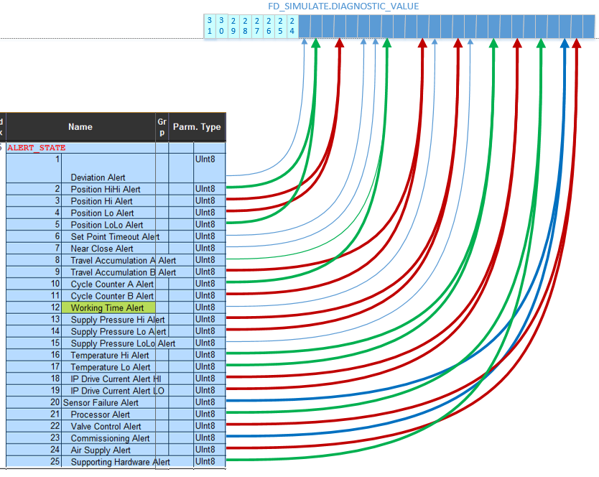

(27333)

# Known issues

It is not possible to upgrade directly from SVI FF Rev.1 to Rev.3, or downgrade from Rev.3 to Rev.1. A workaround is to use an intermediate up/downgrade to Rev.2.

MAI FB doesn’t have a channel to connect to physical analog input. A workaround is to use an AI FB instead.

# Appendix A. Internal improvements

## Build automation

While still work in progress, some automation is in place to allow for guaranteed match of definitions in DD, Softing GW script, and C (26227).

At that, RB parameters can and partially are automated, too (27334). Custom parameters and channels are now documented automatically.

## Quality

Conceptually common features between CPUs now use common API and common code, when possible (26425), esp. i2c (28676)

One-time recalculation of parameters on change units are removed in favor of internal representation (27381, 27390)

Thread-unsafe code has been corrected (multiple)

DD HLP strings match FD enumeration label by automation (60733)

1. 54067 54070
2. 62390
3. Etc.